**People Detection and Counting**

1. **Approaches**

**People Detection and counting approaches:**

1. Python **TensorFlow** and **ImageAI** libraries- Camera feed/image
2. **mmWave Sensor** based approach using IWR applications
3. **TensorFlow and ImageAI Python Libraries**

To perform people detection using ImageAI, following steps must be followed:

1. Download and install Python 3 (preferably Python 3.5) from official Python Language website: [https://python.org](https://python.org/)
2. Install the following dependencies via pip:
3. Tensor Flow: **pip install tensorflow==1.14** (Note: This seems to be the most stable version for the current algorithm. Do not install the default 2.0.0 version as most of the functions and dependencies for the current algorithm is not supported)
4. Numpy: **pip install numpy**
5. SciPy: **pip install scipy**
6. OpenCV: **pip install opencv-python**
7. Pillow: **pip install pillow**
8. Matplotlib: **pip install matplotlib**
9. H5py: **pip install h5py**
10. Keras: **pip install keras**
11. ImageAI: **pip3 install imageai --upgrade**
12. Below is the link to download the **RetinaNet Model file** to be used for people detection.

**Link**: <https://github.com/OlafenwaMoses/ImageAI/releases/download/1.0/resnet50_coco_best_v2.0.1.h5>

File will automatically start downloading.

1. The folder named “**people detetection**” already has the **RetinaNet** **Model file** along with **senzopt_people_detection.py** script file and image to be analyzed named as **“image.jpg”**.
2. Run the Python Script **senzopt_people_detection.py** to start the application. The application computes the total no of detected persons in the image provided named as “**image.jpg”.** A new image named as “**imagenew.jpg”** is generated at the end of computation depicting the persons in the pic in blue square brackets.
3. Below is the sample screenshot of the output for TensorFlow based approach:

**Before:**

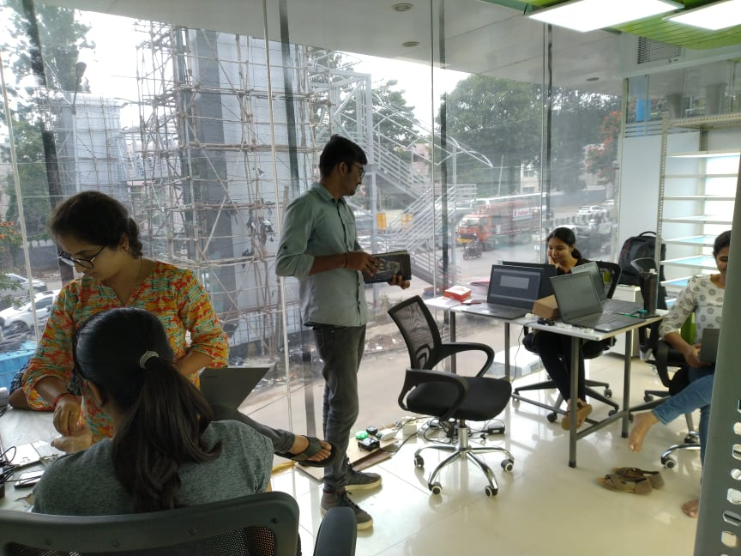

**After:**

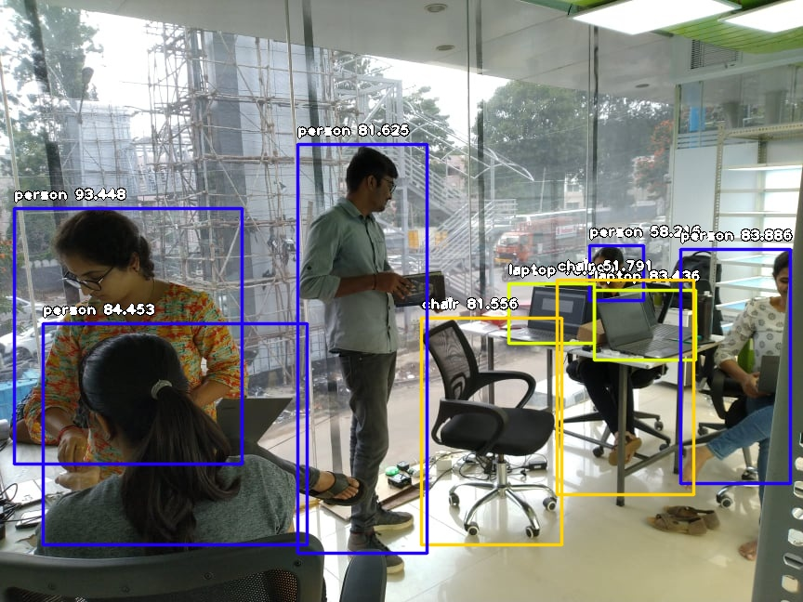

1. **IWR based mmWave Sensors**

TI provides a list of mmWave Sensors based on IWR applications to calculate the people density and count.

**IWR1642 Evaluation Module (IWR1642BOOST) is suggested as the POC module for this purpose. Refer the link below to access the datasheet for the same.**

**IWR1642 EVM:** <http://www.ti.com/lit/ug/swru521b/swru521b.pdf>

Other useful links for the mmWave sensing:

1. <http://www.ti.com/sensors/mmwave/overview.html>
2. <https://www.youtube.com/watch?v=RT56YzqME6M>
3. <http://www.ti.com/lit/ug/swru521b/swru521b.pdf?HQS=TI-null-null-mousermode-df-pf-null-wwe&DCM=yes&ref_url=https%3A%2F%2Fwww.mouser.in%2F>